Cabra For Youth Step Up Referral Form

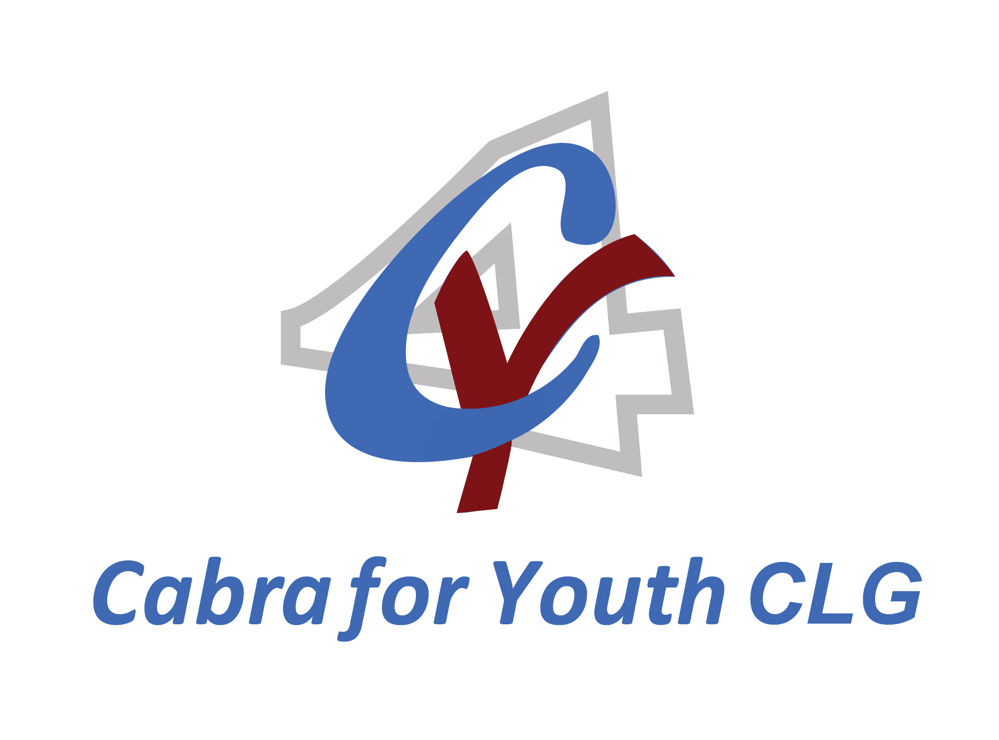
All information included in this form will be kept in accordance with the Data Protection Acts 1998 & 2003.
TO BE RETURNED TO: [YJW/GYDP CONTACT INFORMATION]

Referrer Contact Details
Name of Referrer: |  | Role/Position:
Agency/Service (if applicable):
Address:
Mobile phone: | Email:
Parent/Guardian has consented to the referral (please tick): Yes □ No □
The young person has expressed an interest in attending the project (please tick): Yes □ No □

Young Person’s Details
Young person’s name:
Address:

Mobile phone: | Date of birth:
Name of School/Training Centre/Employment (if applicable):

Parent/Guardian Contact Details
Parent/Guardian’s name:
Address: (if different from young person)

Mobile phone: | Home phone:

JLO Referral Only
Most Recent Offence Type(s):
Formal Caution: Yes □ No □ Informal Caution: Yes □ No □ Date:
Please provide details of any prior cautions or involvement of the young person with the Courts, Probation Service or Detention.

Office Use Only
Outcome from Referral Committee Meeting
Referral (please tick): SUITABLE □ UNSUITABLE □ Date of Decision: ______________

While you may not have information for each of these categories, please indicate (with a tick) the areas of the young person’s life where you may have concerns:
 | Area
1 | Family Circumstances & Parenting (e.g. relationships, supervision, boundaries, discipline, behaviour).
2 | Education/Employment (e.g. behaviour in classroom /at school, relationships with peers and teachers, academic achievement, truancy etc.)
3 | Peer relations (e.g. pro-social or anti-social friends or acquaintances).
4 | Substance Use (e.g. Drug or alcohol use, level of use, impact of use on life).
5 | Leisure/Recreation (e.g. involvement in recreational activities, use of leisure time).
6 | Personality/Behaviour (e.g. physical/verbal aggression, attention span, frustration tolerance, feelings of guilt/remorse, self-esteem).
7 | Attitudes/Orientation (e.g. pro-social/antisocial attitudes, attitude towards authority, empathy, recognition of a problem with behaviour, accepting help).

Referral Information
Please outline reason(s) for referral with reference to the areas indicated above.

Please outline any other relevant information indicating any strengths in the young person and /or their circumstances, other agencies involved, diagnosis, etc.

On receipt of this form contact will be made with the parent/guardian and the young person to conduct a brief screening assessment (the YLS/CMI SV) to aid in assessing suitability for intervention by [GYDP name]. As the referral agent, you may be contacted by the project for additional information. Not all young people referred to the project will be admitted. If this is the case, where possible, alternative services will be suggested. As the referral agent, you will be informed of the outcome of this referral.
I have read and agree to this. Yes □ No □

Signed: _________________________(Referrer) Date: ______________________________

